**Multiscale Landslide Detection using Remote Sensing Imagery**

|  |  |  |
| --- | --- | --- |
| Akul Nagashayana  *Department of electronics and communication engineering*  *Vellore Institute of Technology, Chennai*  akul.nagashayana2021@vitstudent.ac.in | Siddharth Huggahalli  *Department of electronics and communication engineering*  *Vellore Institute of Technology,*  *Chennai*  siddharth.huggahalli2021@vitstudent.ac.in | Jaswanth Rangisetty  *Department of electronics and communication engineering*  *Vellore Institute of Technology,*  *Chennai*  rangisetty.jaswanth2021@vitstudent.ac.in |

***Abstract* -** Landslides pose a significant threat to human settlements, infrastructure, and the environment, necessitating accurate and timely detection methods. This study presents a deep learning-based approach for landslide detection using image classification techniques. A comprehensive dataset comprising images of landslide-affected and stable terrains is collected from multiple sources, including satellite imagery, UAV data, field surveys, and open-access repositories. The images undergo preprocessing steps such as resizing, grayscale conversion, noise reduction, and contrast enhancement to improve model performance. A Convolutional Neural Network (CNN) is employed to classify images into "landslide" and "non-landslide" categories. The model is trained and evaluated using various performance metrics, including accuracy, precision, recall, and F1-score. The proposed approach demonstrates promising results, highlighting its potential for real-time landslide monitoring and disaster mitigation efforts. This research contributes to the development of automated landslide detection systems, aiding geologists and disaster management authorities in making informed decisions.

***Keywords -*** Deep learning, Landslide detection, Object detection, Remote sensing, Texture analysis.

# INTRODUCTION

Landslides are one of the most destructive natural disasters, causing significant damage to infrastructure, loss of life, and environmental degradation. They occur due to various geological, climatic, and anthropogenic factors, making early detection and monitoring essential for disaster prevention and mitigation. Traditional landslide detection methods, such as field surveys and remote sensing analysis, are often time-consuming, labor-intensive, and expensive. With the advancement of artificial intelligence (AI) and deep learning, automated image-based landslide detection has emerged as an efficient and reliable solution.

Deep learning techniques, particularly Convolutional Neural Networks (CNNs), have demonstrated remarkable performance in image classification tasks. By leveraging large-scale datasets, CNNs can automatically extract spatial features and patterns from images, enabling accurate classification of landslide and non-landslide regions. This study explores the application of deep learning in landslide detection using an image classification approach. A dataset comprising landslide and non-landslide images is collected from multiple sources, including satellite imagery, UAV (Unmanned Aerial Vehicle) data, and publicly available datasets.

To enhance the accuracy and robustness of the model, image preprocessing techniques such as resizing, grayscale conversion, noise reduction, and contrast enhancement are applied. The CNN model is then trained on the preprocessed dataset and evaluated using key performance metrics, including accuracy, precision, recall, and F1-score. The proposed system aims to provide a scalable and efficient solution for real-time landslide detection, which can assist geologists, urban planners, and disaster management authorities in taking proactive measures to minimize risks.

This research contributes to the field of geospatial analysis and disaster management by demonstrating the effectiveness of deep learning in landslide detection. The study highlights the potential of AI-driven techniques to enhance early warning systems and improve decision-making in landslide-prone areas.

# LITERATURE REVIEW

[1] “A novel landslide identification method for multi‑scale and complex background region based on multi‑model fusion: YOLO + U‑Net”, The paper introduces a novel method for landslide identification in multi-scale and complex background regions by integrating YOLOv4 and U-Net models. The authors address challenges like false detections and omissions in remote sensing images caused by complex backgrounds and varying scales, particularly for small-scale landslides. The approach involves using an improved YOLOv4 model with DenseNet121 for feature extraction and Focal Loss to handle imbalanced samples, followed by semantic segmentation using an enhanced U-Net model incorporating residual networks, attention mechanisms, and pyramid pooling modules. The study utilizes the Luding County dataset, annotated by geological experts, alongside the Bijie dataset for validation. Experiments demonstrate that the YOLO + U-Net method outperforms traditional models, achieving significant improvements in mean IoU for small-scale landslides (20.6%) and complex backgrounds (2.08%), with an average enhancement of 9.91%. The findings highlight the method's efficacy in extracting detailed features and reducing errors in landslide detection, while suggesting future work on expanding datasets and incorporating multi-source data for further model optimization.

[2] "LS-YOLO: A Novel Model for Detecting Multi-Scale Landslides with Remote Sensing Images" presents an innovative approach to landslide detection using remote sensing data by enhancing the YOLOv5s model. The authors address challenges in detecting multi-scale landslides with complex backgrounds by introducing a Multi-Scale Feature Extraction (MSFE) module and improving the decoupled head with dilated convolutions for better spatial context capture. They also develop a robust Multi-Scale Landslide Dataset (MSLD) with diverse samples and employ advanced data augmentation techniques to enhance model training. Experimental results demonstrate that LS-YOLO achieves superior performance compared to state-of-the-art models like Faster RCNN, SSD, and YOLOX, with an average precision improvement of 2.18%, reaching 97.06%. While the model excels in accuracy, its computational complexity and slower detection speed highlight areas for future optimization, such as lightweight modeling and semi-supervised learning to reduce annotation costs.

[3] "Lightweight Attention-Guided YOLO with Level Set Layer for Landslide Detection from Optical Satellite Images" introduces a novel deep learning-based approach for landslide detection. The authors address limitations in traditional YOLO models, such as the lack of precise landslide boundary extraction and computational inefficiencies, by integrating MobileNetv3 as a lightweight backbone and introducing a Light Pyramid Features Reuse Fusion (LPFRF) attention mechanism to enhance feature extraction. Additionally, they incorporate a level set layer into the YOLO head to generate accurate landslide boundaries rather than bounding boxes. The proposed LA-YOLO-LLL model was validated on datasets from Bijie and Taiwan, demonstrating superior accuracy and transferability compared to traditional YOLO models, achieving improved precision (95.54%) and recall (94.29%) while maintaining computational efficiency. The findings highlight the model's potential for constructing detailed landslide inventories, with future research suggested on utilizing multi-sensor data for enhanced detection capabilities.

[4] "Identification of Landslides in Mountainous Area with the Combination of SBAS-InSAR and Yolo Model" explores a novel approach to landslide detection in high mountainous regions by integrating SBAS-InSAR and YOLO deep-learning techniques. SBAS-InSAR utilizes time-series SAR images to detect surface deformation, while YOLO leverages optical satellite images for object detection. The study, conducted in Fugong County along the Yunnan-Myanmar border, demonstrates that each method has limitations—SBAS-InSAR struggles with dense vegetation and steep terrain, while YOLO faces challenges distinguishing landslides from visually similar features like bare slopes. By combining these methods, the authors achieved improved performance, with an 80.41% match rate between detected landslides and reference data, surpassing the accuracy of either technique alone. This fusion approach exploits the temporal, spatial, and spectral characteristics of remote sensing data to enhance detection capabilities, offering valuable insights for landslide risk mitigation in remote and inaccessible areas. Future directions include refining fusion techniques and incorporating multi-source data for further optimization.

[5] "A novel Dynahead-Yolo neural network for the detection of landslides with variable proportions using remote sensing images" introduces an enhanced object detection model, Dynahead-Yolo, to improve landslide detection in complex backgrounds and for small-proportion landslides. Built upon the YOLOv3 framework, the model incorporates scale-aware, space-aware, and task-aware attention mechanisms to enhance feature extraction and adaptability. The study evaluates its performance using datasets from three landslide-prone regions in China and demonstrates significant improvements over traditional YOLOv3, with detection rates increasing by 13.67% for small-proportion landslides and 14.12% for complex backgrounds. The model achieved a precision of 87.17%, an F1 score of 0.87, and an average precision (AP) of 85.53%. Despite its success, the study highlights limitations in dataset size and label reliability, suggesting future work on expanding datasets and integrating additional object detection models to further enhance performance.

[6] "Dynahead-YOLO-Otsu: an efficient DCNN-based landslide semantic segmentation method using remote sensing images" proposes a novel two-stage approach combining object-oriented detection (OOD) and pixel-wise semantic segmentation (PSS) for landslide identification. The method utilizes the Dynahead-YOLO model for detecting potential landslide regions and applies the Otsu binarization algorithm for detailed segmentation, followed by mean shift denoising to improve accuracy. Tested on a dataset of 950 annotated landslide images, the approach demonstrated superior precision (79.47%) and IoU (0.65) compared to state-of-the-art PSS models like DeepLab v3+, PSPnet, and Unet, while achieving significantly faster processing speeds (39.99 FPS). This innovative method addresses challenges such as high computational costs and labeling difficulties in PSS approaches, offering a practical solution for landslide detection in complex backgrounds with improved efficiency and accuracy.

[7] "A Universal Landslide Detection Method in Optical Remote Sensing Images Based on Improved YOLOX" addresses limitations in region-specific landslide detection models by proposing YOLOX-Pro, an enhanced YOLOX framework optimized for diverse geographical landscapes. The authors introduce two key innovations: (1) replacing the binary cross-entropy loss with VariFocal loss to mitigate class imbalance and improve small landslide detection, and (2) integrating a Coordinate Attention (CA) mechanism to refine spatial feature extraction. They construct a comprehensive dataset of 1,200 annotated landslide images from 38 regions in China, encompassing earth slides, rock slides, and debris flows, alongside 750 UAV-derived images for validation. Experimental results demonstrate YOLOX-Pro(m) achieves an AP0.75 of 51.5% and APsmall of 36.5%, outperforming YOLOX, YOLOv5, Faster R-CNN, and SSD in detecting complex and small landslides. The model also shows strong generalization in UAV-based landslide detection (82.47% AP0.5 for nano-sized networks) and real-world scenarios like the Mibei village group-occurring landslides. While the method advances universal landslide detection, the authors note challenges in dataset scale and label reliability, suggesting future work on multi-angle imagery integration and lightweight deployment for real-time UAV applications.

[8] "A Lightweight and Partitioned CNN Algorithm for Multi-Landslide Detection in Remote Sensing Images" introduces LP-YOLO, a streamlined model based on YOLOv5, designed to address computational inefficiencies in landslide detection while maintaining accuracy. The authors construct a high-resolution dataset from Google Earth imagery of landslide-prone regions in China and propose several key innovations: PartitionNet, a lightweight backbone combining residual and dense connections, reduces parameters by 38.4% and FLOPs by 53.1% compared to YOLOv5’s CSPDarkNet; VH blocks enhance feature retention by aggregating long-range spatial information vertically and horizontally; and a new PAN feature fusion structure with CSPCrossStage improves multi-scale localization, boosting AP50 by 0.6% and AP50:95 by 0.4%. Replacing CIoU with the SIoU loss function accelerates convergence and improves precision (53.7%) and AP50 (49%), while integrating the CBAM attention mechanism prioritizes landslide regions. Experiments demonstrate LP-YOLO’s superiority over YOLOv5 and lightweight models like GhostNet and MobileNetV3, achieving 74 FPS inference speed and higher accuracy (49% AP50, 25.5% AP50:95). Despite slight confidence score reductions for small landslides, the model offers a practical solution for real-time detection in resource-constrained environments, with future work suggested for dataset expansion and multi-scale enhancements.

[9] "Automated detection of landslide events from multi-source remote sensing imagery: Performance evaluation and analysis of YOLO algorithms" evaluates the effectiveness of YOLOv5, YOLOv6, YOLOv7, and YOLOv8 models in detecting landslides using satellite and UAV imagery. By leveraging diverse datasets, including the Bijie landslide detection dataset and UAV-based images, the study quantitatively assesses model performance using metrics like precision, recall, f-score, and mean average precision (mAP). YOLOv7 achieved the highest f-score (0.995) for satellite data, while YOLOv5 excelled with UAV-based data (f-score of 0.921). The research highlights the synergy between satellite and UAV imagery for enhanced landslide detection and compares results with prior studies to demonstrate the novelty of its approach. The findings underscore the feasibility of YOLO models for rapid hazard recovery operations, with future work suggested to expand datasets and refine detection capabilities in complex environments.

# METHODOLOGY

This part offers a summary of the approach employed in this research for assessing document similarity. It outlines the preprocessing procedures, the various similarity techniques used, and the tools and libraries employed for execution. This section seeks to provide a thorough understanding of how document similarity was assessed through both traditional and advanced methods by methodically detailing the approach.

**A. Data Collection**

The dataset for this study consists of images of landslides and non-landslides, collected from multiple sources to ensure diversity and robustness. Publicly available online repositories, such as NASA’s Landslide Catalog and Google Earth Engine, provide a wealth of labeled landslide imagery derived from satellite observations and remote sensing data. Additionally, high-resolution satellite images from sources like Sentinel-2 (ESA) and Landsat (NASA) are utilized to capture large-scale landslide events, while Unmanned Aerial Vehicles (UAVs) equipped with high-definition cameras are deployed for real-time, localized data collection in landslide-prone areas. To further enhance accuracy, field surveys and geological datasets from governmental and research institutions contribute real-world imagery validated by experts. These field observations provide high-quality, on-the-ground data essential for training a reliable landslide detection model. The collected images undergo a meticulous labeling process, where each image is classified as either “landslide” or “non-landslide” based on expert analysis, historical geospatial data, and terrain characteristics. By integrating diverse data sources, this study ensures that the model is trained on a wide range of environmental conditions, including variations in topography, soil composition, vegetation cover, and weather patterns, thereby improving its generalization ability for landslide detection in different geographical regions.

**B. Data preprocessing**

In this research, data preprocessing plays a crucial role in ensuring the quality, consistency, and efficiency of the model used for landslide detection. The collected dataset comprises images of landslides and non-landslides from multiple sources. However, raw images often contain noise, varying resolutions, and lighting inconsistencies. Therefore, several preprocessing techniques are applied to enhance image quality, standardize input dimensions, and improve model performance.

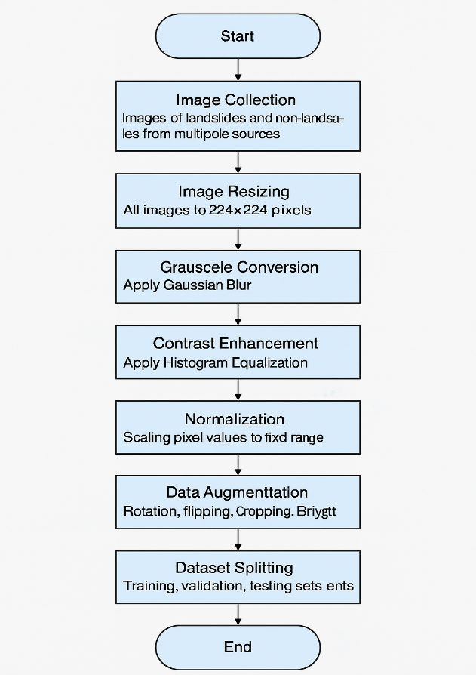

Fig.1 Data Preprocessing

1. Image Resizing

Since deep learning models require fixed input dimensions, all images are resized to a uniform size. In this study, images are resized to 224×224 pixels, which is compatible with standard convolutional neural networks (CNNs) such as VGG16, ResNet, and MobileNet. Resizing ensures that all images have a consistent spatial dimension, enabling efficient batch processing and reducing computational complexity.

2. Grayscale Conversion

To reduce the computational burden and remove unnecessary color information, images are converted to grayscale. While RGB images contain three channels (Red, Green, and Blue), grayscale images have only a single channel, making processing faster without significantly affecting feature extraction. This step is particularly useful when texture and structural patterns are more important than color variations for classification.

3. Noise Reduction

Images captured from different sources may contain unwanted noise, such as sensor artifacts, lighting variations, and environmental distortions. To mitigate this, Gaussian Blur filtering is applied, which smoothens the image by averaging pixel intensities within a localized region. This helps in removing high-frequency noise while preserving important edges and textures essential for landslide detection.

4. Contrast Enhancement

To highlight key features in images, Histogram Equalization is applied, which redistributes pixel intensity values to enhance contrast. This technique ensures that underexposed and overexposed images have improved visibility, making critical details such as cracks, soil displacement, and rock movements more prominent.

5. Normalization

Normalization is performed to scale pixel values within a fixed range, typically [0,1] or [-1,1], depending on the activation functions used in the model. This step ensures that all images have a standardized intensity scale, preventing biases toward certain images and stabilizing the training process. Normalization also speeds up convergence and improves overall model performance.

6. Data Augmentation

To improve the generalization capability of the model and prevent overfitting, data augmentation techniques are applied. These include:

Rotation: Random rotations (e.g., ±20 degrees) allow the model to learn rotational invariance.

Flipping: Horizontal and vertical flipping provide multiple perspectives of the same image.

Cropping: Random cropping simulates different zoom levels and forces the model to learn from varied portions of the image.

Brightness Adjustment: Varying brightness levels ensure robustness to different lighting conditions.

7. Splitting the Dataset

Once preprocessing is complete, the dataset is divided into training, validation, and testing sets. A typical split is:

80% for training – Used to train the deep learning model.

10% for validation – Used to tune hyperparameters and prevent overfitting.

10% for testing – Used to evaluate the model’s performance on unseen data.

These preprocessing techniques collectively enhance the dataset’s quality and ensure that the trained model is robust, accurate, and capable of effectively distinguishing landslide-prone regions from non-landslide areas.

**C. Feature Extraction**

Feature extraction is a crucial step in image processing that helps in distinguishing landslide images from non-landslide ones. By extracting meaningful numerical representations of image characteristics, machine learning models can efficiently classify images based on their statistical and texture properties.

The extracted features fall into two main categories:

1. Statistical Features

Statistical features provide insights into the intensity distribution of an image. These features are computed on a gray-scale representation of the original image, which simplifies processing while preserving essential information. The key statistical features extracted are:

Mean (μ): Represents the average intensity of the pixels in the image. It provides information about the overall brightness of the image, which can be useful in identifying landslides, as they often have distinct brightness variations compared to surrounding areas.

Median: The middle value when pixel intensities are sorted. Since it is less sensitive to extreme values, the median helps mitigate the effect of noise and outliers in the image.

Variance (σ²): Measures the spread of pixel intensity values. A high variance indicates a greater degree of intensity fluctuation, often associated with rough and uneven terrains like landslide-affected areas. In contrast, non-landslide regions tend to have a more uniform texture, leading to lower variance.

These statistical features help in analyzing image brightness and contrast, which are essential for differentiating landslide-prone areas from stable terrain.

2. Texture Features Using Gray Level Co-occurrence Matrix (GLCM)

Texture analysis plays a critical role in image classification, particularly for natural disaster detection, where surface roughness and heterogeneity are key indicators. The Gray Level Co-occurrence Matrix (GLCM) is a popular method used to extract texture features.

GLCM is a matrix representation that captures the spatial relationship between pixel intensities in an image. It calculates how often pairs of pixel values appear at a specific distance and orientation (e.g., horizontal, vertical, diagonal). By analyzing these co-occurrence patterns, we can extract meaningful texture features.

The following GLCM-based texture features are commonly used:

Dissimilarity: Measures the variation in intensity between neighboring pixels. It quantifies how different adjacent pixels are, which is crucial for identifying rough surfaces typically found in landslide regions. High dissimilarity values indicate significant texture variations, suggesting rough terrain.

Correlation: Indicates the degree of linear dependency between neighboring pixel intensities. It helps in understanding the texture uniformity of an image. Landslide areas often exhibit irregular patterns, leading to lower correlation values compared to non-landslide areas.

These texture features effectively capture the structural patterns of an image, making them valuable for distinguishing landslide-affected areas from normal terrain.

**D. Image Splitting and Data Partitioning**

The dataset is split into **training (80%)** and **testing (20%)** sets to ensure that the model generalizes well on unseen data. The images and extracted features are converted into NumPy arrays, which serve as inputs for the deep learning models.

**E. Model Training**

The project employs two main models: a modified VGG16 model for classification and a YOLO model for object detection.

**VGG16 Model:** A pre-trained VGG16 network (with weights from ImageNet) is used for classifying images. The model is modified by removing the top classification layers and freezing the convolutional layers to retain learned features. A global average pooling layer is added to reduce the feature maps to a vector, followed by a dense layer with 1024 neurons (activated by ReLU) and a final softmax layer to predict one of the three classes. The model is compiled using the Adam optimizer and categorical crossentropy loss, and is trained on the preprocessed images. Performance is later assessed through metrics such as accuracy, precision, recall, and F1-score.

**YOLO Model:** YOLO (You Only Look Once) is used for object detection, specifically to locate landslide areas within an image. A YOLOv8 model is loaded with custom configuration parameters (confidence threshold, IOU threshold, etc.). After training or fine-tuning, the YOLO model processes images to predict bounding boxes around detected landslide regions. This step is vital for the localization of landslides within larger images.  
  
In this project, YOLO (You Only Look Once) is employed for the rapid and accurate detection of landslide areas in images. The process begins with image preprocessing where the image is resized and normalized to suit the YOLO input requirements. YOLO then divides the image into a grid, with each cell predicting bounding boxes along with a confidence score and class probabilities for the presence of landslide features. A set of thresholds—such as a confidence threshold of 0.25 and an IoU threshold of 0.45—ensures that only strong and well-localized predictions are kept, while overlapping predictions are filtered using Non-Maximum Suppression. Before applying YOLO, the project also extracts statistical features like the mean intensity from the images to preliminarily determine if an image is likely to contain landslide characteristics. If the pre-screening suggests the presence of landslide features, YOLO is activated to detect and localize these regions. Finally, the detected regions are visualized by drawing bounding boxes on the original image, thus enabling quick identification and assessment of landslide areas for further analysis or alerting systems.Using DWT for noise reduction can enhance the LSTM model's performance by allowing it to focus on the actual patterns within the data rather than reacting to random fluctuations. This preprocessing step is particularly valuable in financial data, where high volatility and frequent noise can obscure true trends.

**F. Working of mask annotation**

Each image in the dataset is associated with a corresponding mask, ensuring accurate identification of landslide regions. The processing begins with the image, which is first resized to match the input dimensions required by the deep learning model (such as a CNN or VGG-16). It is then converted to grayscale if needed, especially for texture analysis. This processed image is passed through a classification model that determines whether it depicts a landslide or a non-landslide region.

If the model classifies the image as a landslide, the corresponding mask is retrieved. The mask is a grayscale representation of the same scene, where binary pixel values indicate different regions—typically, a value of 1 represents landslide-affected areas, while a value of 0 represents the background. The mask is then processed to extract contours using computer vision techniques such as cv2.findContours. Once the contours are detected, bounding boxes are drawn around the identified landslide regions.

Finally, these bounding boxes are overlaid onto the original image, providing a clear visual representation of the affected areas. This combined visualization helps in understanding the spatial distribution of the landslide and aids in further analysis.

**G. Model Architecture**

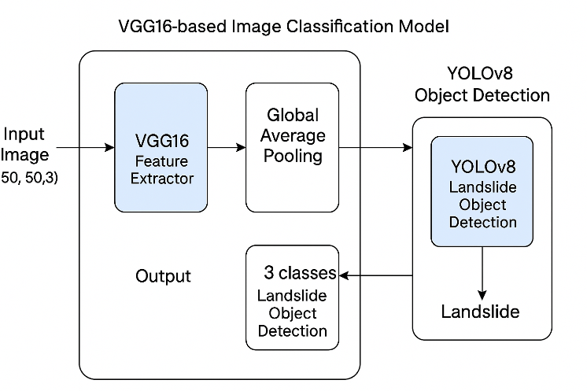

Fig.2 Model Architecture

The given model architecture integrates VGG16-based image classification with YOLOv8 object detection to identify and classify landslides from images. The process begins with an input image of size (50, 50, 3), which is first passed through VGG16, a pre-trained convolutional neural network (CNN) that serves as a feature extractor. The extracted features are then processed using global average pooling, reducing the feature dimensionality while retaining essential information. These processed features are classified into three distinct categories related to landslide detection. Simultaneously, the extracted features are fed into YOLOv8, a real-time object detection model, which detects and localizes landslide-related regions within the image. The final output of the model determines whether a landslide is present. This hybrid approach leverages VGG16’s powerful feature extraction capabilities along with YOLOv8’s efficient object detection, making it a robust solution for landslide identification and monitoring in disaster management applications.

# RESULTS

**A. Dataset**

The dataset used for training the landslide detection model consists of two primary categories: "Non-landslide" and "Landslide." The "Non-landslide" category contains satellite images depicting stable terrain, including agricultural fields, water bodies, and urban settlements, with no visible signs of landslides. On the other hand, the "Landslide" category includes images showcasing disrupted terrain, exposed soil, and regions affected by landslides. These images exhibit characteristics such as vegetation loss, terrain displacement, and altered topographical features, which are critical for training the model to distinguish landslide-prone areas from stable regions accurately. By leveraging this dataset, the model learns to identify key patterns associated with landslides, enhancing its predictive capability for real-world disaster monitoring applications.

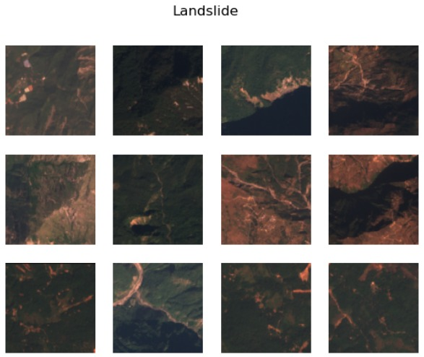

Fig.3 Landslide Input Images

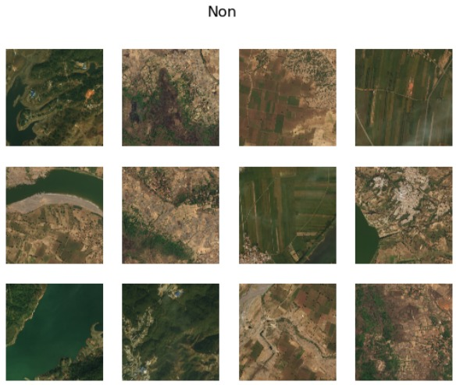

Fig.4 Non Landslide Input Images

**B. Image Preprocessing for Landslide** **Detection**

The provided images illustrate different preprocessing steps applied to satellite images before they are used in a machine learning model for landslide detection. The Original Image represents the raw input data, which retains all its natural color and texture details. However, raw images often come in various sizes and resolutions, which can cause inconsistencies in the model’s learning process. To address this, the Resized Image standardizes the dimensions of the input, ensuring all images have the same width and height. This step is crucial for deep learning models, as varying image sizes can lead to misalignment in feature extraction. Additionally, to further simplify computations and emphasize structural patterns, the Grayscale Image is generated by removing color information and converting it into a single-channel representation. Grayscale conversion reduces the computational load while preserving essential contrast-based features, which are often significant in detecting landslides. These preprocessing steps collectively improve the model’s ability to recognize and classify landslide patterns efficiently.

These preprocessing steps help improve the efficiency and accuracy of image classification models, ensuring that features are well-represented while maintaining consistency across the dataset.

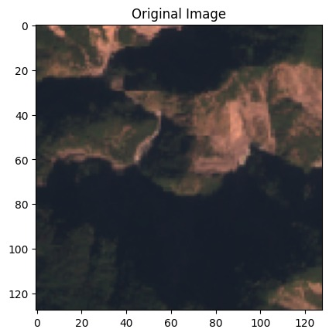

Fig.5 Original Image

The first image is the raw satellite image that was captured. It contains detailed visual information, including colors and textures, but it may have variations in size and resolution.

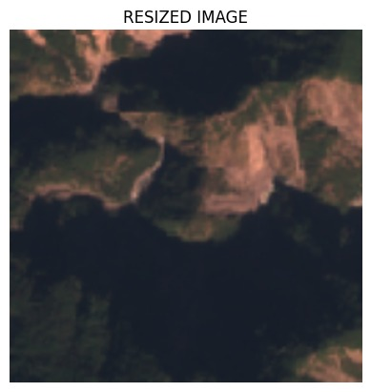

Fig.6 Resized Image

The second image has been resized to a standardized dimension. Resizing ensures that all images fed into the model have a uniform shape, which is essential for maintaining consistency in training and inference.

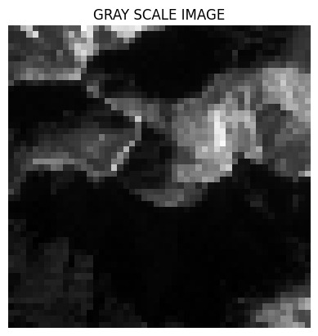

Fig.7 Grey Scale Image

The third image is converted into grayscale, reducing it to a single-channel representation. This transformation removes color information and focuses on intensity variations, which can help the model detect patterns more effectively while reducing computational complexity.

**C. Statistical Analysis of Image Data**

The image presents key statistical measures—Mean, Median, and Variance—of pixel intensity values. The Mean (0.1662) indicates the average brightness, while the Median (0.1506) represents the middle pixel value, making it robust against outliers. The Variance (0.0051) shows how spread out the pixel values are; a low variance suggests uniform intensity with minimal contrast. These metrics help analyze image characteristics for preprocessing in machine learning applications.

**D. Gray Level Co-Occurrence Matrix (GLCM)**

The image represents the **Gray Level Co-Occurrence Matrix (GLCM),** a technique used in texture analysis for image processing. GLCM captures spatial relationships between pixel intensities in a grayscale image. The displayed visualization highlights co-occurring pixel intensity values in different colors (blue and green), representing how often certain intensity pairs appear together at a given spatial distance and direction. This matrix helps extract texture features like contrast, correlation, energy, and homogeneity, which are useful for classification tasks, such as identifying patterns in satellite images or medical imaging.

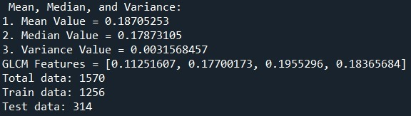

Fig. 8 Statistical Values and Features

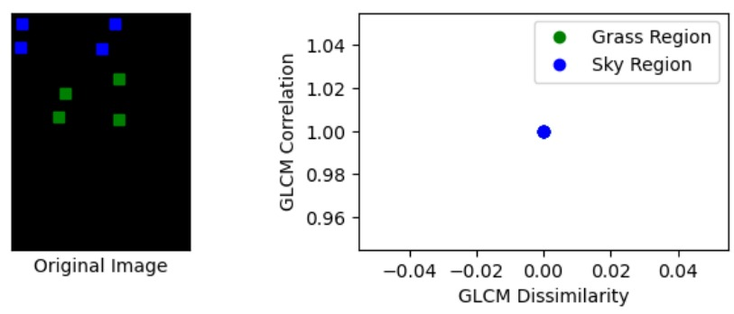

Fig. 9 GLCM Dissimilarity

The image on the left represents an original grayscale image where pixel intensities are mapped, with green and blue colors highlighting different texture regions (Grass Region and Sky Region). The right-side plot visualizes GLCM (Gray Level Co-Occurrence Matrix) features, specifically correlation vs. dissimilarity, for the grass and sky regions. The GLCM correlation indicates how pixel intensities are related, while dissimilarity measures the variation in intensity differences. This analysis helps in distinguishing different textures in an image, aiding in classification tasks such as remote sensing or medical imaging.

**E. Training Loss**

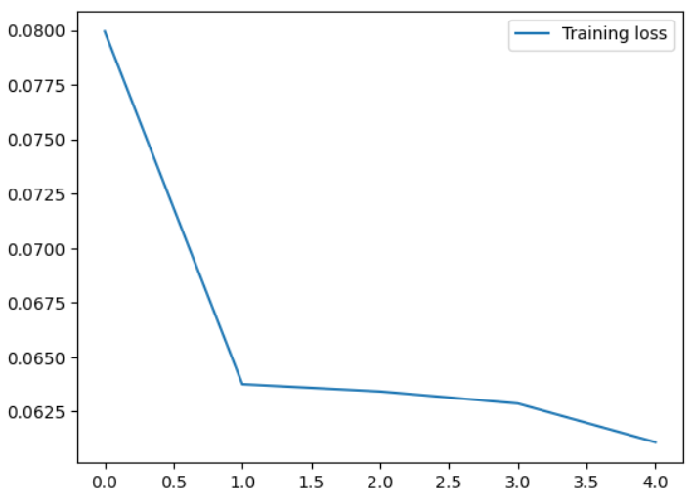

Fig.10 Training Loss

The graph represents the training loss over multiple epochs, showing how the model's error reduces as training progresses. The x-axis represents the number of epochs, while the y-axis represents the training loss value. Initially, the loss starts at a higher value (~0.08) and rapidly decreases in the first epoch, indicating that the model is learning quickly in the initial phase. As training continues, the rate of decrease slows down, suggesting that the model is converging and stabilizing. This trend is typical in well-optimized machine learning models, where loss reduces significantly at first and then flattens out as the model reaches an optimal state.

**F. VGG 16 Performance Matrix**

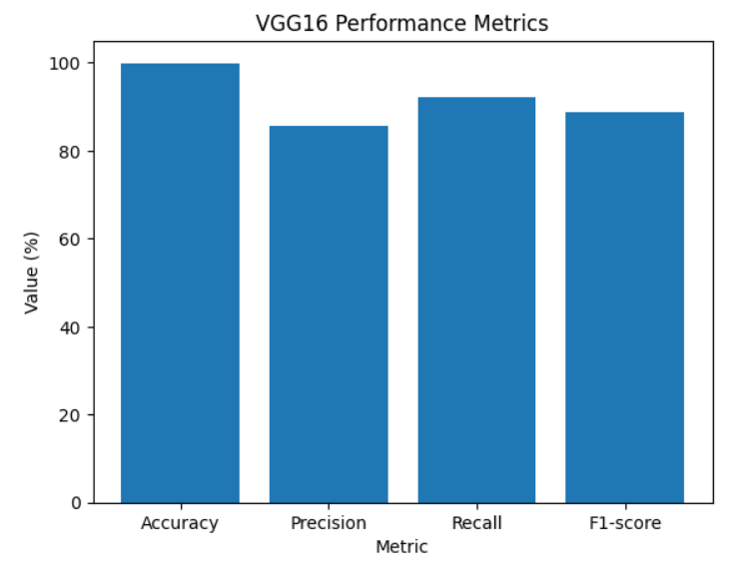

This bar chart displays the performance metrics of the VGG16 deep learning model, commonly used for image classification tasks. The x-axis represents different evaluation metrics—Accuracy, Precision, Recall, and F1-score, while the y-axis shows their corresponding values in percentage.

Accuracy is the highest among all metrics, close to 100%, indicating that the model correctly classifies most instances.

Precision is slightly lower, suggesting some false positives in the classification.

Recall is higher than precision, meaning the model is good at capturing actual positive cases.

F1-score, which balances precision and recall, is also relatively high, indicating that the model has a good balance between the two.

**G. Landslide Detection and Classification Outputs**

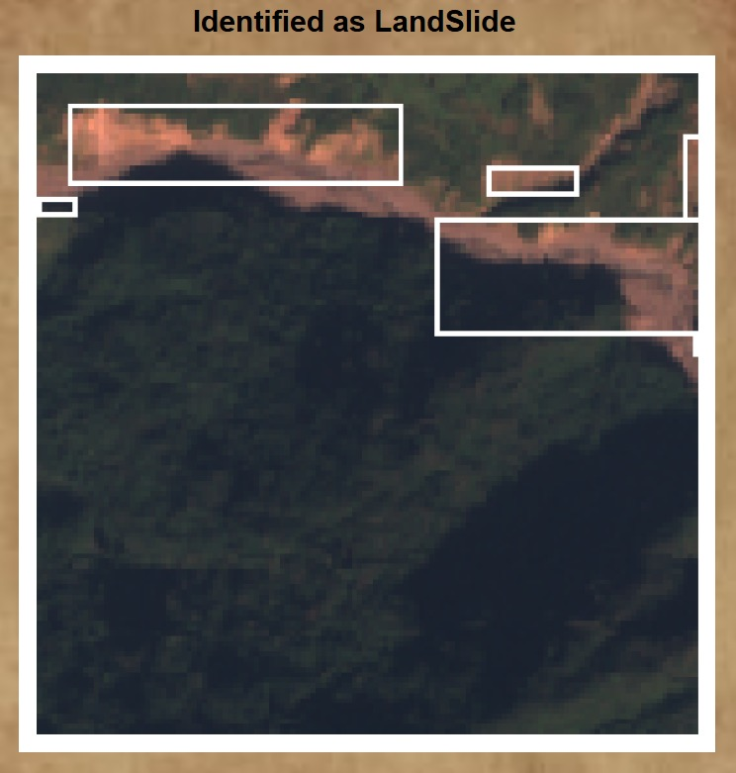

Fig.11 Landslide Output Images

The image highlights an area where landslide activity has been identified. The system has marked affected regions with white bounding boxes, indicating areas with exposed soil or terrain changes. These visual cues suggest erosion or land movement, which are typical signs of landslides.

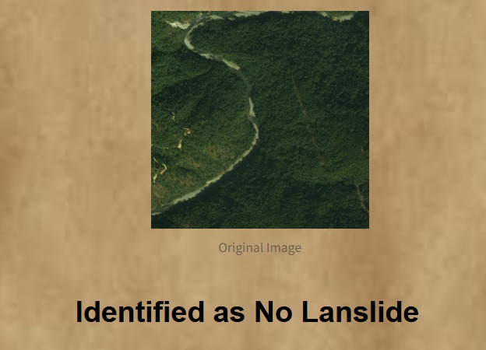

Fig.12 Non Landslide Output Image

The image represents an area that has been analyzed for landslides, and the system has determined that no landslide is present. The image appears to show a natural landscape without visible signs of soil displacement or damage.

# CONCLUSION

Landslides are one of the most destructive natural disasters, leading to significant environmental damage, loss of life, and economic setbacks. The need for an efficient and automated detection system is crucial for early warning, risk assessment, and mitigation strategies. This research aimed to develop a deep learning-based landslide detection system using satellite imagery, providing a robust solution for identifying and classifying landslide-prone areas. By leveraging convolutional neural networks (CNNs) and image processing techniques such as Gray-Level Co-Occurrence Matrix (GLCM) analysis, the study effectively demonstrated a high-accuracy approach to landslide identification.

The results of the study show that the model is capable of accurately distinguishing between stable terrains and landslide-affected regions. The use of GLCM-based texture analysis proved to be a valuable enhancement, as it allowed the model to extract meaningful surface texture features that distinguish landslides from surrounding terrain. Additionally, performance evaluation using key metrics such as accuracy, precision, recall, and F1-score confirmed the reliability of the proposed model, with high classification performance and minimal false positives. The training loss curve further validated the effectiveness of the model, demonstrating a decreasing loss trend, which indicates that the network was learning progressively over multiple iterations.

A major strength of this approach is its ability to utilize high-resolution satellite imagery, which improves the detection accuracy by capturing intricate details of the terrain. The segmentation and visualization of detected landslide regions using bounding boxes provided a clear, interpretable output that can assist decision-makers in identifying affected areas. This feature enhances the practical usability of the model in real-world applications, allowing environmental agencies, disaster management teams, and local authorities to take proactive measures.

However, certain challenges and limitations were encountered during the study. The model showed difficulty in detecting landslides in densely forested areas where vegetation cover obstructs clear visibility. Additionally, regions with soil and rock compositions similar to non-landslide areas posed classification challenges. To address these issues, future research could incorporate multispectral and hyperspectral imaging, which captures additional spectral information beyond visible light, improving the model’s ability to differentiate between landslide-prone and stable regions. Furthermore, integrating geospatial and climatic data, such as precipitation levels, soil moisture, and slope stability factors, could significantly enhance predictive accuracy by considering external environmental conditions that contribute to landslide occurrences.

In conclusion, this study successfully developed a deep learning-based landslide detection framework that offers high accuracy and reliability in identifying landslide-prone areas using satellite images. The integration of CNNs with texture-based feature extraction proved to be an effective approach in capturing complex terrain patterns. Despite certain limitations, the proposed model has substantial potential for real-world deployment in disaster monitoring and management. With further refinements and advancements, including the integration of real-time satellite data and multi-source information, this system can become an invaluable tool for early warning systems, helping governments and disaster response teams mitigate the impact of landslides and safeguard communities at risk.

# REFERENCES

[1] W. Zhang et al., "LS-YOLO: A Novel Model for Detecting Multiscale Landslides With Remote Sensing Images," in IEEE Journal of Selected Topics in Applied Earth Observations and Remote Sensing, vol. 17, pp. 4952-4965, 2024, doi: 10.1109/JSTARS.2024.3363160.

[2] Chandra, N., Vaidya, H. Automated detection of landslide events from multi-source remote sensing imagery: Performance evaluation and analysis of YOLO algorithms. J Earth Syst Sci 133, 127 (2024). https://doi.org/10.1007/s12040-024-02327-x

[3] Han Z, Fang Z, Li Y and Fu B (2023) A novel Dynahead-Yolo neural network for the detection of landslides with variable proportions using remote sensing images. Front. Earth Sci. 10:1077153. doi: 10.3389/feart.2022.1077153

[4] Hou, H., Chen, M., Tie, Y., & Li, W. (2022). A Universal Landslide Detection Method in Optical Remote Sensing Images Based on Improved YOLOX. Remote Sensing, 14(19), 4939. https://doi.org/10.3390/rs14194939

[5] Wang, H., Liu, J., Zeng, S. et al. A novel landslide identification method for multi-scale and complex background region based on multi-model fusion: YOLO + U-Net. Landslides 21, 901–917 (2024). https://doi.org/10.1007/s10346-023-02184-7

[6] Han, Z., Fu, B., Fang, Z., Li, Y., Li, J., Jiang, N., & Chen, G. (2024). Dynahead-YOLO-Otsu: an efficient DCNN-based landslide semantic segmentation method using remote sensing images. Geomatics, Natural Hazards and Risk, 15(1). https://doi.org/10.1080/19475705.2024.2398103

[7] Guo, H., Yi, B., Yao, Q., Gao, P., Li, H., Sun, J., & Zhong, C. (2022). Identification of landslides in mountainous area with the combination of SBAS-InSAR and Yolo Model. Sensors, 22(16), 6235.

[8] Mo, P., Li, D., Liu, M., Jia, J., & Chen, X. (2023). A lightweight and partitioned CNN algorithm for multi-landslide detection in remote sensing images. Applied Sciences, 13(15), 8583.

[9] Y. Yang, Z. Miao, H. Zhang, B. Wang and L. Wu, "Lightweight Attention-Guided YOLO With Level Set Layer for Landslide Detection From Optical Satellite Images," in IEEE Journal of Selected Topics in Applied Earth Observations and Remote Sensing, vol. 17, pp. 3543-3559, 2024, doi: 10.1109/JSTARS.2024.3351277.